SLP13. Body Parts

Pair #
STOP: Before you begin this activity, open and follow recording instructions here.

Partner A:
Student ID:
Instructor:
Language:
Level: Date:
Partner B:
Student ID:
Instructor:
Language:
Level: Date:

Section 1: Vocabulary Mastery
Instructions: Describe the sign of the following words and phrases using the 5 Parameters of ASL. Try to use your book and your partner before using other materials or the internet. Use the third column to help you remember the sign in your target language (ASL) by drawing a picture or writing a note to yourself.
Vocabulary | 5 Parameters of ASL Description | Notes/Pictures/Sign Guide  (anything to help you)
- face
- smile
- eyes
- nose
- mouth
- neck
- shoulders
- arms
- wrist
- fingers
- palm
- belly/stomach
- legs
- thigh
- knee
- ankle
- foot
- hair
- scar
- best (facial) feature

Section 2: Translation
Instructions: Take turns writing these sentences using ASL syntax (word order). Remember that you may not be able to write evert English word for a sign. You should keep the same basic meaning in your target language (ASL).
- Does your friend have long hair?
- Your best feature is your nose.
- The guitar player has long fingers.
- My father has big feet, but he has small hands.
- What color is your wife’s hair?
- That man has a scar on his face.

Section 3: Label the Body
Instructions: Label the picture of Homer Simpson with the correct body parts by indicating if it’s fingerspelled, pointed to, or has a sign.
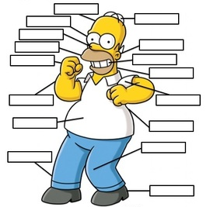

Section 4: Creating a Dialogue
Partner A: You are sending your partner to pick up your friend at the airport. Describe your friend so your partner can find them easily in the crowd.
Partner B: Ask specific questions about this friend so that you will have a clear picture in your mind.
Write your conversation here. Attach another piece of paper if you need more space. You will record this dialogue in the next section. Ask for help when necessary.
Signer 1:
Signer 2:
Signer 1:
Signer 2:
Signer 1:
Signer 2:
Signer 1:
Signer 2:

