LP15. Daily Routine

Pair #
STOP: Before you begin this activity, open and follow recording instructions here.

Partner A:
Student ID:
Instructor:
Language:
Level: Date:
Partner B:
Student ID:
Instructor:
Language:
Level: Date:

WAIT! If you haven’t learned how to tell time in your target language, you may want to complete LP7 before completing LP15.

Section 1: Vocabulary Mastery
Instructions: Write the translation of the following words and phrases into your target language. Try to use your book and your partner before using other materials or the internet. In the third column, draw a picture, write a note to yourself or put some kind of pronunciation guide for the target language. Use the third column to help remember your target language.
Vocabulary | Translation | Notes/Pictures/Pronunciation Guide (anything to help you)
- To wake up
- To shower
- To brush one’s teeth
- To brush one’s hair
- To get dressed
- To eat (breakfast/lunch/ dinner)
- To go to sleep
- To put on makeup
- To work
- To go to school
- To go shopping
- To study
- To watch TV
- To read a book
- To walk the dog

Section 2: Translation
Instructions: Translate the following into your target language. Try to use your book and your partner before using other materials or the internet.
- When do you get up?

- My mom wakes up at 7:00am and takes a shower.
- Camila brushes her hair and puts on makeup.
- Camila studies at 5pm on Tuesdays.
- When do you go to sleep?
- I go to sleep at 11pm.

Section 3: What is Jackson’s Daily Routine?
Instructions: Look at the pictures to learn about Jackson’s daily routine. Then, translate the questions on the following page. Take turns asking and answering the questions with your partner using the pictures.
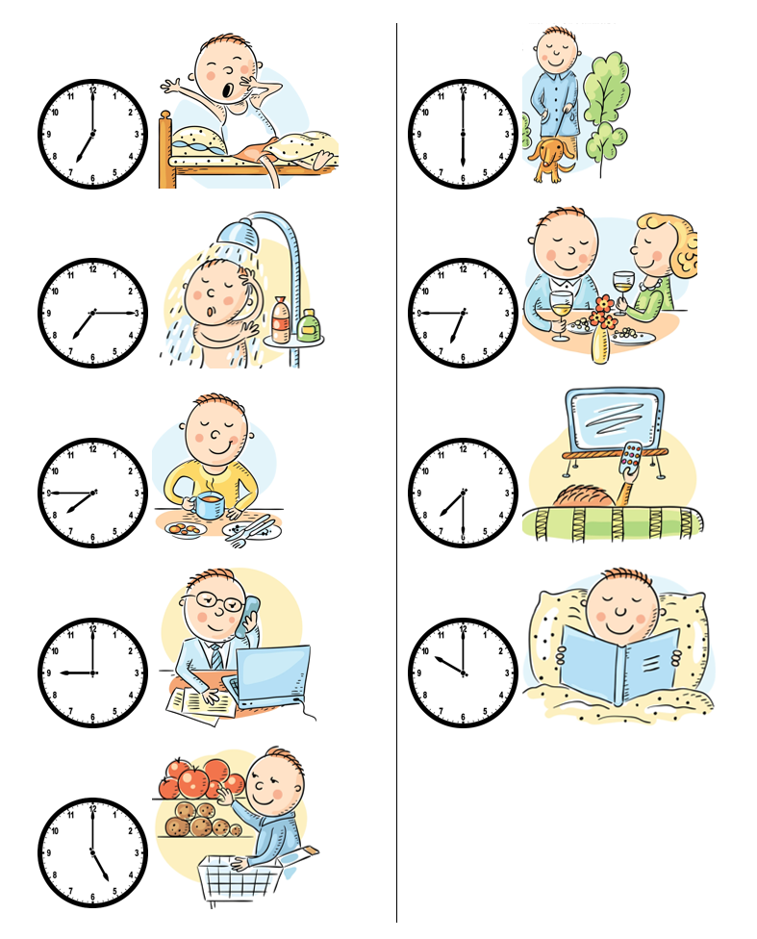

Instructions (continued from page 3): Translate the questions on this page. Try to use your book and your partner before using other materials to help you. Take turns asking and answering the questions with your partner using the pictures from page 3.
- When does Jackson wake up?
- What does Jackson do at 7:15AM?
- When does Jackson eat breakfast?
- What does Jackson do at 9:00AM?
- When does Jackson go shopping?
- What does Jackson do at 6:00PM?
- What does Jackson do at 6:45PM?
- When does Jackson watch TV?
- What does Jackson do at 10:00PM?

Section 4: Creating a Dialogue
Instructions: You and your partner will ask and tell each other about your daily routine. You can ask questions similar to the ones on the previous page, but make sure to use “you” forms instead of “he/she.” Write your conversation here. Continue below if you need more space. You will perform this dialogue in the next section.
Speaker 1:
Speaker 2:
Speaker 1:
Speaker 2:
Speaker 1:
Speaker 2:
Speaker 1:
Speaker 2:

Section 5: Perform Your Dialogue
Instructions: Perform the dialogue you created with your partner. Make sure you do not end your Zoom meeting until you have performed your dialogue with your partner.

