LP8. Friends and Emotions

Pair #
STOP: Before you begin this activity, open and follow recording instructions here.

Partner A:
Student ID:
Instructor:
Language:
Level: Date:
Partner B:
Student ID:
Instructor:
Language:
Level: Date:

Section 1: Vocabulary Mastery
Instructions: Write the translation of the following words and phrases into your target language. Try to use your book and your partner before using other materials or the internet. In the third column, draw a picture, write a note to yourself or put some kind of pronunciation guide for the target language. Use the third column to help remember your target language.
Vocabulary | Translation | Notes/Pictures/Pronunciation Guide (anything to help you)
- I am
- You are (singular/plural, formal/informal if applicable)
- He is
- She is
- We are
- They are
- Happy/sad
- Disgusted /angry
- Gentle/kind/funny/patient
- Optimistic/pessimistic
- Afraid/arrogant
- Lazy/selfish/bossy/energetic/active
- Responsible/smart
- Beautiful/ugly
- Modern/old/antique
- Rich/poor
- Slim/thin/fat

Section 2: Identify Emotions
Instructions: Label the following traits using the vocabulary from Section 1. Use your target language.
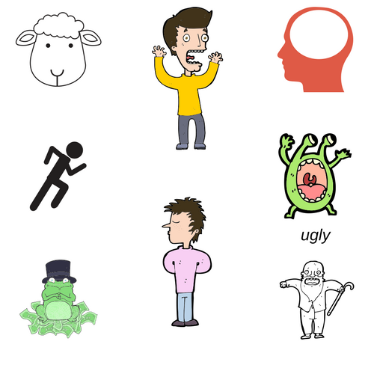

Section 3: Sentence Completion
Instructions: Take turns finishing these sentences and translating them into your target language. Practice speaking with your partner.
Example: Today I feel excited.
- Today I feel: __________________________________________
- Yesterday I felt: ________________________________________
- After class I feel: _______________________________________
- After I study I feel: _____________________________________
- After work I feel: ______________________________________
- I like people who are: ___________________________________
- My friends are: ________________________________________
- I dislike people who are: _________________________________
- Today my mom is: _____________________________________
- Today my dad is: _______________________

Section 4: Dialogue Creation
Instructions: Your partner will ask you about a friend. Find a picture of a friend or family member on your phone. Use three adjectives to describe your friend. Switch roles and ask your partner about a friend. Write your conversation here. Continue below if you need more space. You will perform this dialogue in the next section.
Speaker 1:
Speaker 2:
Speaker 1:
Speaker 2:
Speaker 1:
Speaker 2:
Speaker 1:
Speaker 2:

Section 5: Perform Your Dialogue
Instructions: Perform the dialogue you created with your partner. Make sure you do not end your Zoom meeting until you have performed your dialogue with your partner.

