LP3. Home

Pair #
STOP: Before you begin this activity, open and follow recording instructions here.

Partner A:
Student ID:
Instructor:
Language:
Level: Date:
Partner B:
Student ID:
Instructor:
Language:
Level: Date:

Section 1: Vocabulary Mastery
Instructions: Write the translation of the following words and phrases into your target language. Try to use your book and your partner before using other materials or the internet. In the third column, draw a picture, write a note to yourself or put some kind of pronunciation guide for the target language. Use the third column to help remember your target language.
 | Translate into Target Language | Notes/Pictures/Pronunciation Guide (anything to help you)
- an oven
- a bathroom
- a couch
- a kitchen
- a bedroom
- a chair
- a bed
- a living room
- a refrigerator
- a rug
- an apartment

Section 2: Verbal Expressions
Instructions: Write the expressions used when talking about a home, a house, or the furniture. Practice speaking with your partner taking turns.
Ask: “Where is the kitchen?” (translate)
Answer: “Here is the kitchen.” (translate)
Practice asking and answering with each item on the vocabulary list.
Ask: “Where is the ?”
Answer: “Here is a/the .”

Section 3: Interior and Exterior Home Description
Instructions: Draw rectangles to represent furniture in the house. Label the rooms. Use your textbook and your partner’s help to talk about the interior and exterior parts of this home.
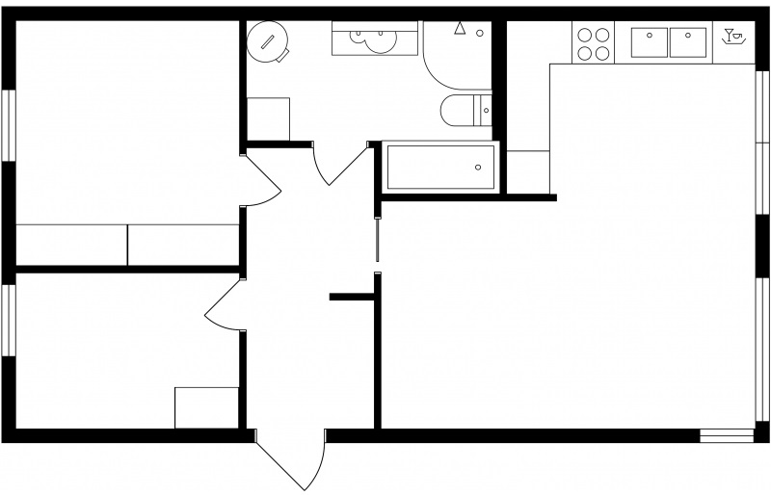

Section 4: Dialogue Creation
Instructions: Write the questions you will ask your partner about their own house in the target language. Then write your partner’s answers in the target language. Practice asking and answering. Switch roles and then answer your partner’s questions. Continue below if you need more space. You will perform this dialogue in the next section.
Speaker 1:
Speaker 2:
Speaker 1:
Speaker 2:
Speaker 1:
Speaker 2:
Speaker 1:
Speaker 2:

Section 5: Perform Your Dialogue
Instructions: Perform the dialogue you created with your partner. Make sure you do not end your Zoom meeting until you have performed your dialogue with your partner.

