KLP17 Weather and Seasons
STOP: Before you begin this activity, open and follow recording instructions for online activities or on-campus activities.

Pair # __________

Partner A: ________________________________
Student ID: _______________________________
Instructor: ________________________________
Level: ______________ Date: _________________
Partner B: ________________________________
Student ID: _______________________________
Instructor: ________________________________
Level: ______________ Date: _________________

All links in this activity direct to the KLP Activities page on the LLC website. Find your activity number and click the drop down to find links to videos used in this activity.

Section 1: Vocabulary Mastery
Instructions: Write the translation of the following words and phrases into Korean. Try to use your book and your partner before using other materials or the Internet. In the third column, draw a picture, write a note to yourself or put some kind of pronunciation guide for the target language. Use the third column to help remember your target language.
Vocabulary | Translation | Notes/Pictures/Pronunciation Guide (anything to help you)
- Spring
- Summer
- Fall
- Winter
- Season
- Chill factor
- Fahrenheit
- Celsius
- Temperature
- Foliage
- To get higher
- To get lower
- To be hot
- To be humid
- To become cooler
- To get colder
- To get cloudy
- To be clear, sunny
- To snow
- To be dirty

Concept Check: Change of state ~어/아지다
~어/아 지다 is attached to adjectives to express a change from one state to another. This construction is very useful when you want to talk about a change that is taking place or that has already taken place or will take place. This form is great to use when talking about seasonal changes and weather changes. However, it does not have to be weather. It can be anything. In many cases, the past tense would be more appropriate since the state has already changed. Make sure you choose the appropriate tense when using ~어/아 지다.
To conjugate , conjugate the adjectives into the 어요/아요 form and then drop e요. Then add 지다.

흐리다 흐려요 흐려져요 흐려졌어요 흐려질 거예요
덥다 더워요 더워져요 더워졌어요 더워질 거예요
시원하다 시원해요 시원해져요 시원해졌어요 시원해질 거예요
맑다 맑아요 맑아져요 맑아졌어요 맑아질 거예요
많다 많아요 많아져요 많아졌어요 많아질 거예요
Example sentences:
한국 봄 날씨가 너무 좋아요. 그런데 여름에는 덥고 습해져요.
어제는 눈이 왔어요. 그래서 추워졌어요.
내일은 기온이 올라가고 더워질 거예요.

Section 2: Sentence Translation
Instructions: Take turns translating the following sentences into Korean. Then practice asking and answering. In your response, make sure you use the ~어/아지다 form. Write down your partner’s answers in Korean.
*Remember: Do not to translate “you” in Korean. It is understood from the context.

- How is the weather these days?
_______________________________________________________________________
- Your room was messy. Did you clean your room?
_______________________________________________________________________
- Your mother was ill. How is she now?
_______________________________________________________________________
- How has the weather changed?
______________________________________________________________________________________
- How is Korean 3?
_______________________________________________________________________
- You work and study. How has your schedule changed?
_______________________________________________________________________
- I want to eat Korean food. Are there any Korean restaurants in Walnut?
_______________________________________________________________________

Section 3: Changes
Instructions A: Look at each picture and discuss with your partner how things have changed using the ~어/아지다. Use the vocabulary words from the vocabulary section.
Instructions B: You and your partner can talk about things that have changed. Look at the prompts below and talk to your partner how things have changed. Pick 3 topics to talk to your partner.
A:
Example:
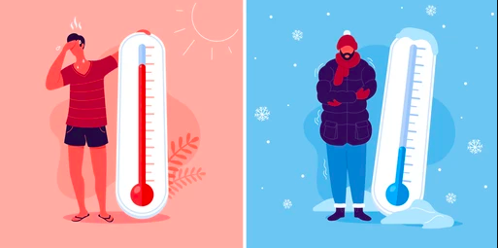
기온이 높아졌어요. 기온이 낮아졌어요.
(Continue on next page.)

1.

        
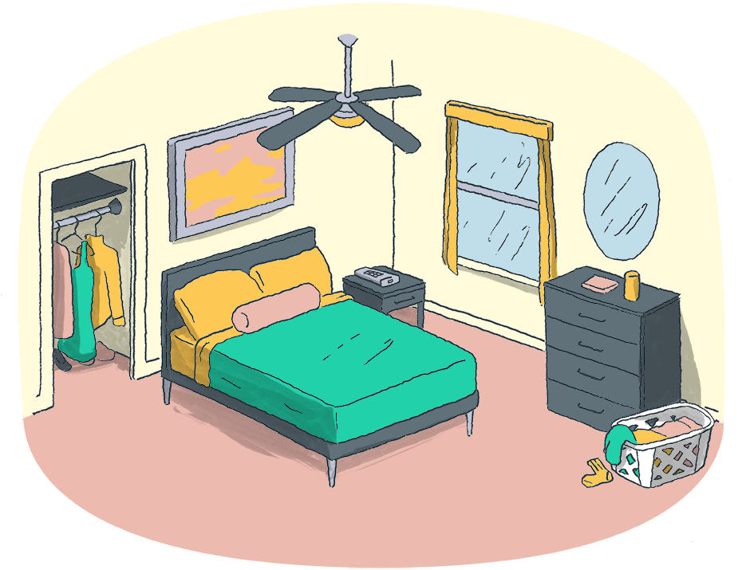

2.

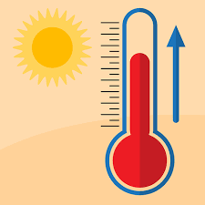
 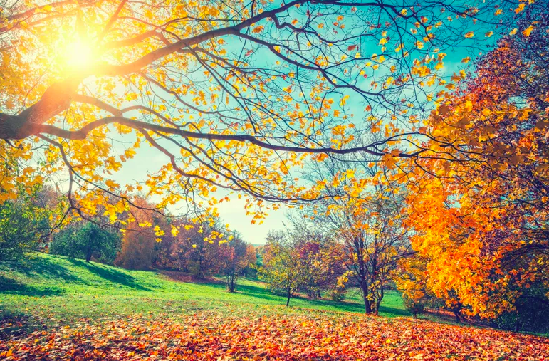

3.

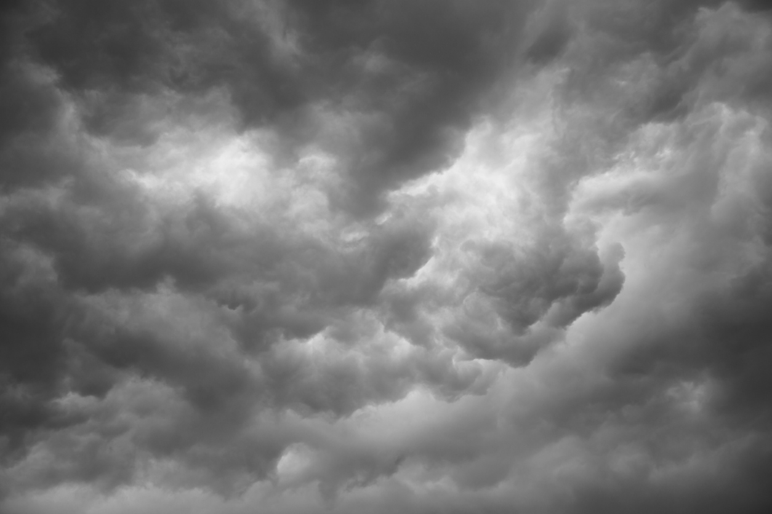
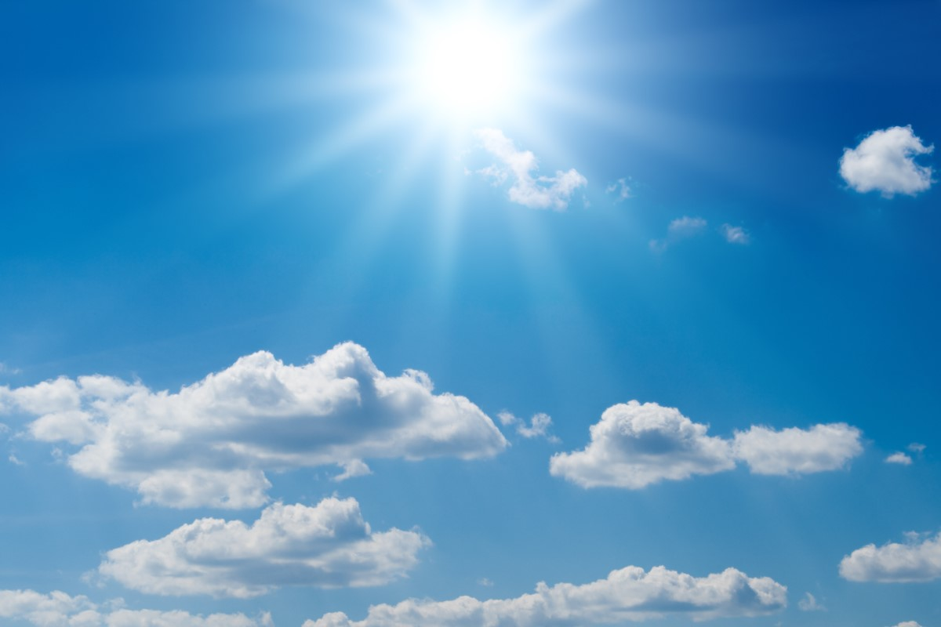

4.

5.

6.

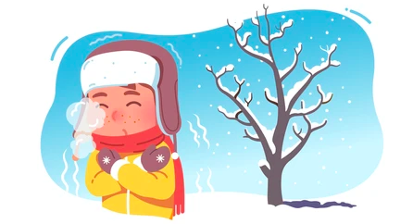

B. 어떻게 달라졌어요? Pick 3 to talk to your partner.
1. 고등학생 ➔대학생
2. 한국어 수업 전 ➔ 한국어 수업 후
3. 코로나 전 ➔ 코로나 후
4. 운동 전 ➔ 운동 후
5. 학생 ➔ 회사원

Section 4: Favorite Season
Part A: You and your friend are sitting outside the library watching the leaves change. You can talk about your favorite season. Translate and practice the following conversation with your partner in Korean.
A:
Speaker 1: The temperature has dropped these days.
Speaker 2: Yes, the weather has become cooler. By the way, what is your favorite season?
Speaker 1: I like winter because the weather turns cold. I like wearing sweaters. What about you?
Speaker 2: I like fall because the leaves change colors. And the weather turns clear. The fall sky is beautiful.
Speaker 1: I love the fall weather, too. I love persimmons and pears.
Speaker 2: Me too. I eat a lot in the fall season. My money disappears.

Part B: You and your partner are planning a trip to Korea. Discuss which season is the best and plan a trip. Use the space below to help create the conversation. The conversation should be 30 seconds to 1.5 minutes for beginning levels and longer for upper levels. You will record this dialogue in the next section. Ask for help if necessary.
B:
Speaker 1:__________________________________________________________
Speaker 2: __________________________________________________________
Speaker 1: __________________________________________________________
Speaker 2: __________________________________________________________
Speaker 1: __________________________________________________________
Speaker 2: __________________________________________________________

Section 5: Record and Save Your Recording
Instructions: Perform the dialogue you created with your partner. Make sure you do not end your Zoom meeting until you have performed your dialogue with your partner.

