Student Health Insurance Card
Print ID Card Step-By-Step Instructions:
1. Go to hyperlink: http://www.studentinsuranceusa.com
2. Hover your mouse over “Student Insurance”, International Students” then click Print ID Card.
3. You will be directed to the Aetna website
4. Select “Your college or university.” Then, select Mt. San Antonio College. Then, click “View your school.”
5. Select, “Print your ID card.”
6. Enter your Student ID number (without the A), and your birth date. Example May 1, 1980 is: 05011980
7. Click Submit. Then click on the “Print ID card.”
8. For any assistance, please call Student Insurance at 800-367-5830
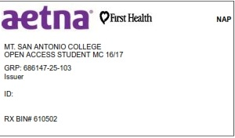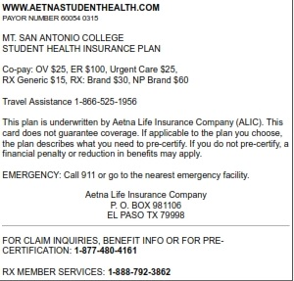
Print and Keep This Card and Keep with You AT ALL TIMES

