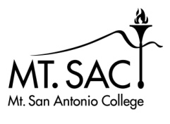
Distance Learning Committee
2021-22

PURPOSE: The purpose of the Distance Learning Committee is to discuss, review, and evaluate distance learning modes of instruction, and recommend and promote best practices and new opportunities for distance learning and teaching.

FUNCTION: The Committee's functions are to:
- evaluate and recommend approval of Distance Learning Course Amendment Forms
- recommend policy and processes pertaining to distance learning
- evaluate and promote a variety of effective practices and standards for distance learning that foster student equity and success
- support sharing and collaboration among distance learning faculty by working with the Faculty Center for Learning Technology, Information Technology, Faculty Professional Development Council, and the Faculty Learning Activities Committee
- facilitate the development of an ongoing Distance Learning Plan
- coordinate with campus committees and other constituencies with regards to distance learning
- support accreditation processes

X | Matthew Dawood | X | Michael Dowdle | X | Luis Echeverria-Newberry | X | L.E. Foisia | X | Hong Guo
X | Mike Hood | X | Carol Impara, co-chair |  | Tammy Knott-Silva | X | Catherine McKee | X | Stacie Nakamatsu
X | Michelle Newhart | X | Romelia Salinas, co-chair | X | Eric Turner | X | Sandra Weatherilt | X | Student Rep:  Carlos Romero
Guest: Katie Datko

MINUTES – April 26, 2022

AGENDA ITEM | DISCUSSION/COMMENTS
Approval of DLC minutes:  April 12, 2022 | Approved
Reports:
Educational Design Committee (EDC) /Curriculum and Instruction Council (C&I) (Carol) | DLC minutes of March 8 accepted.
Information Technology Advisory Committee (ITAC) Report | ITAC met April 4, 2022.  - John Uy from Associated Students (AS) proposed we create a workspace similar to the Student Hub in Canvas for the AS to communicate items such as club information to students. This request may be referred to CATT (Canvas and Teaching Technology).  - Michael Carr discussed the Student Print Management System. Places are set up around campus for students to print.  - Anthony Moore discussed a pilot program using T-Mobile hotspots. The T-Mobile hotspots are less costly than those from Verizon. If the pilot program goes well, a change to T-Mobile may be prudent.
Faculty Learning Activities Committee (FLAC) Report (Catherine) | FLAC met for the first time on April 19. The committee discussed calendaring for the usual POD activities (One Book One Campus, Teaching from the Back of the Room, Inspired Teaching Conference, etc.) and will meet again on May 4. Eva is also on the committee. Any input on what we’d like scheduled, and when?
Faculty Center for Learning Technology (FCLT) Report (Michelle) | SPOT Recertification Workshops are on the POD Calendar and open for registration. The workshop will be Fri May 13.  - 10am Regs Update  - 11:15am eIntegrity  - 12:30pm 5 Tools/Accessibility Champ  - 1:45pm Humanizing Course/Introduction  Self-paced recert options are also available!  Peralta Equity Conference is Wed-Fri this week, free to attend and sessions will be recorded and available on youtube.  Reminder: FCLT survey is ongoing. Please fill out/encourage others to fill out.
Student Report | Associated Students Court  A.S is looking for associated justices during the 2022-2023 academic year. Applications are due May 9, 2022. Students may apply through the A.S website.  Grad Fest  Saturday, May 21, 2022, at 10:00 am – 4:00 pm  Mountie Mentor 2022  Open to Mt. SAC students, staff, faculty and administrators. The event will feature a keynote speaker, concurrent workshop sessions for you to choose from, and a closing performance. May 13th – 8:00 am – 1:00 pm – Bldg. 13  Meditation Under the Stars  Every Tuesday & Wednesday from 3:00 – 3:45 pm in the planetarium.
DL Amendment Forms
GEOG 9  GEOG 12  GEOG 13  GEOG 14  GEOG 15  GEOG 16  MATH 10A  MATH 130  LING 4 | Approved with topic edits  Approved with topic edits  Approved with topic edits  Approved with topic edits  Approved with topic edits  Approved with topic edits  Approved  Approved  Approved  The forms were corrected and moved to EDC on April 28.
Discussion
ASCCC Resolution Passed | See resolution passed at Plenary, below.
Academic Senate Direction to DLC | The DLC was directed to address the following issues by Academic Senate Exec on April 14, 2022.  - Review and update REC Rubric previously passed by Senate to address RSI (regular and substantive interaction)  - Update AP 4105, and  - Develop process for RSI review  - Make recommendations for supporting DL faculty in the transition from REC (regular and effective contact) to RSI (regular and substantive interactive). [RSI compliance is the legal federal requirement that distinguishes the status of courses between distance education and correspondence courses.]
AP 4105 | A working draft of AP 4105 is in OneDrive. This meeting will include a big-picture review in hopes of approving the AP next meeting to move forward to C&I and Senate.  - Committee members contributed comments to a Summary of Changes document. The DLC reviewed the AP through Enrollment and Attendance in Distance Learning Courses.  - Does the revision include all necessary sections? Should there be sections added or deleted? – Authentication and Privacy were separated into two sections.  - Do we need to form an offline workgroup to redo certain sections? - Authentication: Sandra, Catherine, L.E. will wordsmith this section. 20% verbiage: please ask your department colleagues to weigh in on this section.  - Will this revised AP answer your colleague’s questions?
RSI Rubric and Process | Senate Exec has tasked us with revising the REC Rubric and suggesting a process to audit regular substantive interaction in online courses.  - OneDrive resources: REC Rubric, process examples from other community colleges (ACCJC presentation), important questions from the ACCJC Formative/Summative Review Guide.  - What is the best way to approach this task?  Carol, Catherine, L.E., Mike D., Hong, Katie, and Michelle will work offline on this project.
POCR Team | The POCR Team is pleased to announce we have certified our tenth faculty course as Quality Reviewed under the SEAP Grant. Mt. SAC has a total of 22 Quality Reviewed courses that are aligned to the CVC Course Design Rubric. See screenshot below for complete list of QR Faculty.  How can we market Course Alignment and the POCR Process better to the campus? – tabled due to lack of time
CVC Update | Please see information from April 15 DECO meeting, below.
See you next meeting!

Spring 2022 semester dates – 8 meetings – as needed (finals week, summer are possible)
DLC Meetings - 2nd and 4th Tuesdays at 1:15 – 2:45 PM online via Zoom
DLC website: https://www.mtsac.edu/dlc/
DLC listserv: dlc@mtsac.edu

DLC Accreditation Themes:
- IB9. Assuring Academic Quality and Institutional Effectiveness Academic Quality – Engages in continuous, broad based, systematic evaluation and planning
- IIA. Instructional Programs – Uses delivery modes, including DL, in support of equity
- IIB. Library and Learning Support Services – Provides library and other learning support services to support educational programs, including DL
- IIC. Student Support Services – Evaluates and demonstrates that student support services support student learning in various modes, including DL
- IIIC. Technology Resources – Provides support in the use of technology
- IIIA14. Human Resources – Provides all personnel with appropriate opportunities for continued professional development.

The following courses had course identifier changes and the DL Forms were updated to reflect these changes. No other changes were made to the course.

AGAN 1 à ASCI 1- Animal Science
AGAN 2 à ASCI 2 - Animal Nutrition
AGAN 51 à ASCI 51- Animal Handling and Restraint

AGLI 14 à ASCI 14 - Swine Production
AGLI 16 à ASCI 16 - Horse Production
AGLI 96 à ASCI 96 - Animal Sanitation and Disease Control

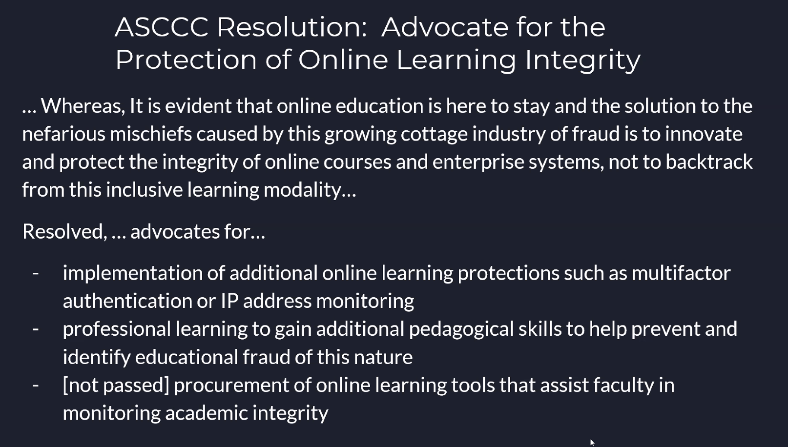

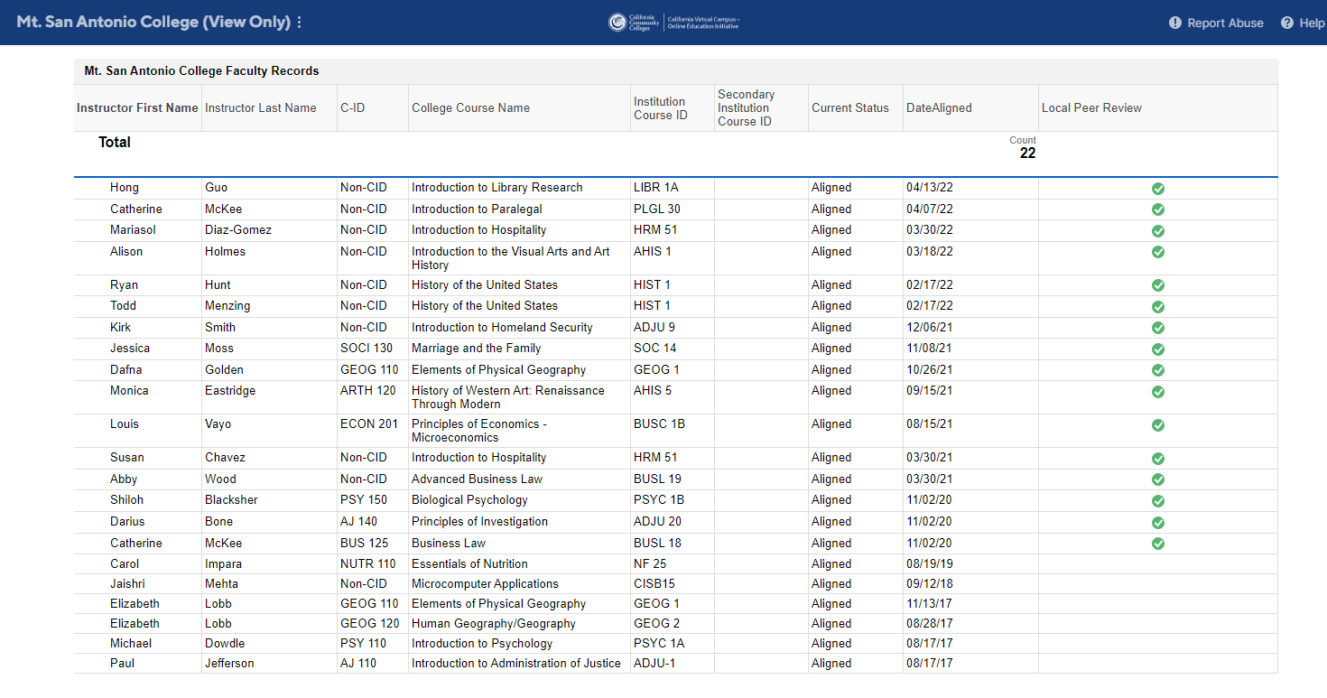
Figure 1. Quality Reviewed courses as of April 21, 2022.
CVC Report
