Distance Learning Committee (DLC)

Report to Academic Senate

May 5, 2022

New Process Debut – SPOT Equivalency (SPEQ)

New SPOT Equivalency Process (approved by Academic Senate in December 2021) rolled out in April.

Faculty will earn SPOT Equivalency if they can provide documentation of online teaching certification from certain other California community colleges, they submit a Canvas course, and the course passes an expedited SPOT-style review. Further information, including the list of approved colleges, can be found at the SPOT Equivalency webpage.

We are only accepting certifications from the listed colleges, which were approved by the Distance Learning Committee (DLC). We are only accepting those colleges' full certification. We will not be accepting the equivalent of our FOMAR training as SPOT Equivalent.

Please direct interested faculty to the SPOT Equivalency webpage and encourage them to contact Catherine McKee with their SPEQ (and SPOT) questions. Both processes will be open over the summer.
Please contact Catherine McKee, Assistant Distance Learning Coordinator, for more information. cmckee@mtsac.edu.

SPOT Update

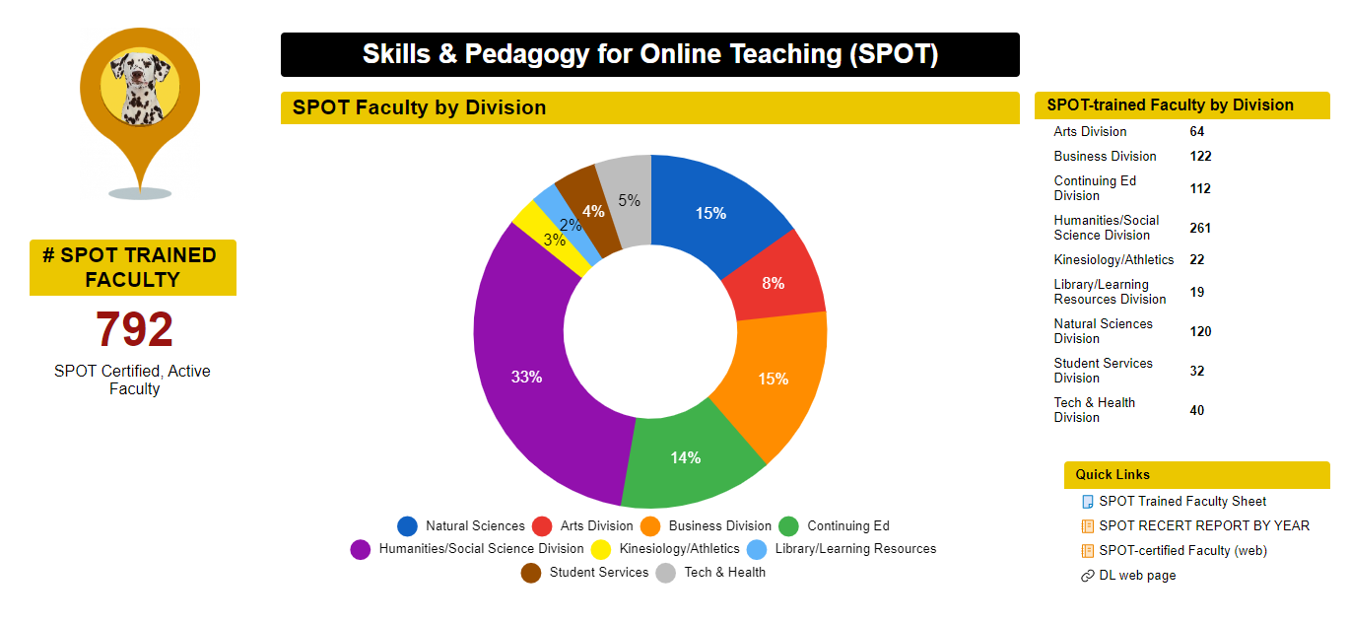
There are 792 SPOT certified faculty!

SPOT Recertification Training Dates

The FCLT is offering a synchronous SPOT Recertification Intensive on May 13, 2022! Attendance will fulfill SPOT Recertification requirements. Attend one or all. Sign up via POD Connect Calendar.
- 10 – 11 a.m. - Regulations Update for SPOT Recertification
- 11:15 – 12:15 p.m. - Strategies for Developing eIntegrity
- 12:30 – 1:30 p.m. - 5 Tools to Make You an Accessibility Champ
- 1:45 – 2:45 p.m. - Humanizing Your Online Course – An Introduction

If you are not free Fridays, or prefer asynchronous options, note that the following self-paced sessions have been approved for SPOT Recertification and are available through POD. You may find them under the “Featured Training” list on the homepage, or check the course cards under Connect Home.
- Regulations Update for SPOT Recertification (online)
- Easy and Engaging Videos in Canvas Studio, Part 1 (online)
- Easy and Engaging Videos in Canvas Studio, Part 2 (online)
- Aligning Your Online Course with Section D of the CVC Rubric: Laying the Foundation (online)

Please check out the SPOT Recertification webpage for more information.
17 of 37 SPOT-certified faculty have achieved SPOT recertification before their July 31, 2022 due date.

AP 4105 Revision; Accreditation Processes

The DLC is currently revising AP 4105, which was last updated in 2016. It should be ready to go to C&I in May. DLC was directed to review the REC (regular effective contact) Rubric created by the REC Rubric Task Force, update the rubric to reflect RSI (regular substantive interaction), and recommend a process for RSI review. The DL program will launch a survey to determine faculty needs this Spring.

Distance Learning Amendment Forms

DLC approved about 256 DL Forms since May 1, 2021. Academic Senate is voting on using the Smartsheet method of DL Amendment Form submission. After the form is approved, we will update the webpage. https://www.mtsac.edu/dlc/dl-forms.html

POCR Update

Since September 2021, the POCR team has aligned 11 courses. The POCR team is seeking continued funding. The SEAP Grant is expiring as of June 31, 2022.

Respectfully submitted,
Carol Impara
Distance Learning Faculty Coordinator
POCR Lead
cimpara@mtsac.edu

