Distance Learning Committee (DLC)

Report to Academic Senate

March 4, 2021

Faculty Facilitators
Need a little last-minute help setting up or refining your online course? Faculty Facilitators are here to help! Seven faculty experienced in online teaching and Canvas can answer your setup and design questions. (Note: faculty cannot help you with enrollment or Banner issues. Contact IT for those questions.) Faculty facilitators may now be reached through the email facfac@mtsac.edu.

Here’s a handy flow chart to help you decide how to seek help!

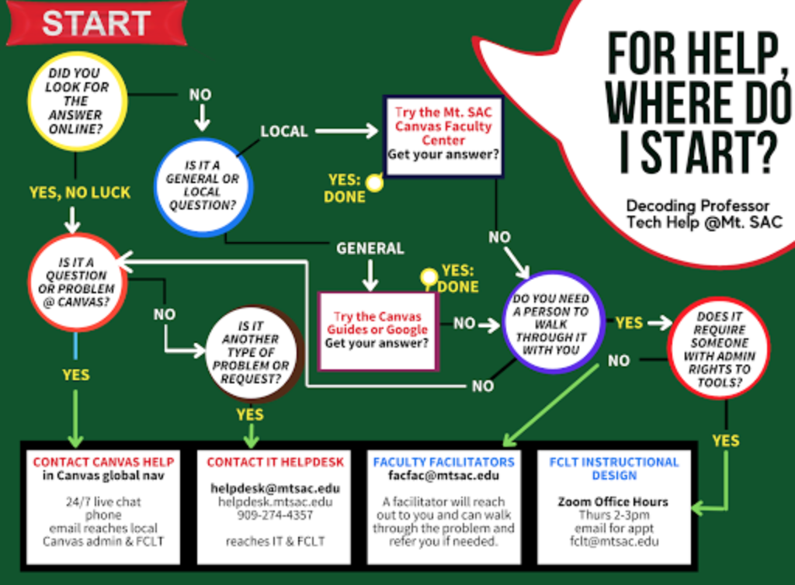

Faculty Facilitators: facfac@mtsac.edu
Canvas Faculty Center: Self enroll on the home page (scroll down). https://mtsac.instructure.com/courses/54
Contact Canvas Help via your Canvas Help Icon

SPOT Report

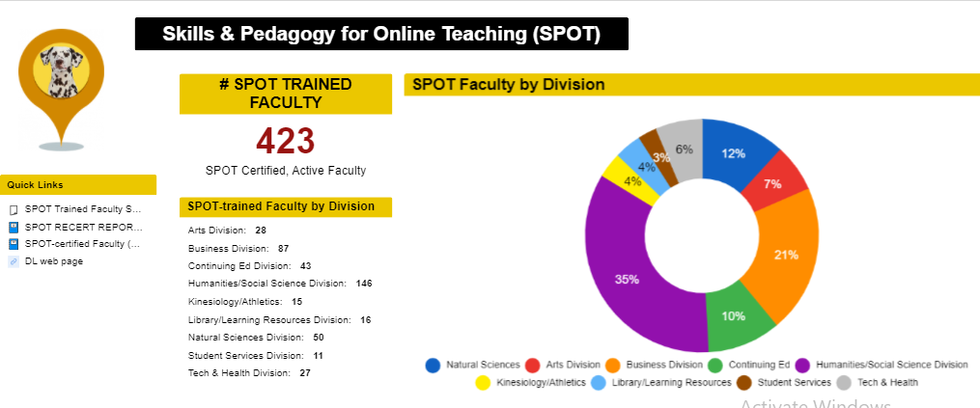
Since this graphic was created, a few more people were SPOT certified – there are currently 427.
- Humanities has the largest percentage of SPOT-certified faculty, followed by Business.
- Notable is Continuing Ed. Before the pandemic, there were no SPOT-certified Continuing Ed faculty. Now, they comprise 10% of SPOT certified faculty.

Current SPOT Data:
- 507 SPOT sign-ups since March 2020
- Almost 600 faculty currently in SPOT
- 51 submitted courses in the review queue now

SPOT submission “deadlines”
Use these dates as a guideline for SPOT submission. Actual certification timing depend on original course condition, faculty responsiveness,task completion, and accessibility issues.
- March 1 for certification by summer 2021
- June 1 for certification by fall 2021 (possibly May 1 if SPOT is required for fall)

SPOT Recertification
- Congratulations to the 136 faculty who achieved recertification by their December 31, 2020 deadline.
- Congratulations to the 16 faculty who have already achieved recertification before their July 31, 2021 deadline.
  - 7 faculty still have recertification due 7/31/21.
- Three FLEX day sessions were approved for recertification. We will be announcing other recertification sessions soon.
- For updates on recertification, or to submit your evidence, please visit the SPOT Recertification webpage:
https://www.mtsac.edu/distancelearning/spotrecert.html

DL Amendment Forms
- Since March 2020, DL Amendment forms for more than 450 courses have been approved by EDC. An additional 285 have been approved by DLC and are moving to EDC.
- The DL Amendment form faculty workgroup is working through WebCMS submissions. We are on “M.”
  - The workgroup reviews between 30-40 forms per week.
- Faculty can submit DL Amendment forms either by WebCMS OR the Smartsheet-linked form. Use WebCMS for FOMA courses. Use either method for “traditional” courses.
- Thank you, faculty, for submitting your forms and for responding to my questions. We are getting through this together!

AP 4105
The DLC has begun a review of AP 4105, which was last updated 2016. Many regulations have changed and there will need to be substantial revision.

Respectfully submitted,
Carol Impara
Distance Learning Faculty Coordinator

