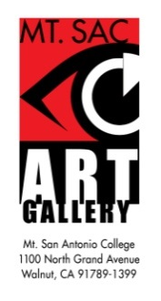

Faculty Exhibition
March 2017

[ ] Yes, I would like to confirm my participation in the Faculty Exhibition scheduled
for March 23-April 20, 2017. I will submit a minimum of either three
small pieces or two large pieces, with the understanding that due to design
constraints, some of the work may not be exhibited.

[ ] No, I am unable to exhibit at this time.

Number of pieces I will be submitting .

Although the selection of work will take place later on, please indicate the
approximate insurance value of either two large pieces or three small pieces
of your work. The approximate insurance value is $ .

Date: _______________ ____________________________________
Artist’s Signature or Representative’s Signature

Printed Name of Artist

Address:

Phone:

Email:

Please sign and return this form to Fatemeh Burnes mailbox, located in building 1A, no later than November 30, 2016. If you have any questions please contact Cynthia Orr at x4328. We may also be reached by email at corr@mtsac.edu.

*Please note that all participants in the Faculty Exhibition must be current Faculty members at the time of the exhibition.

